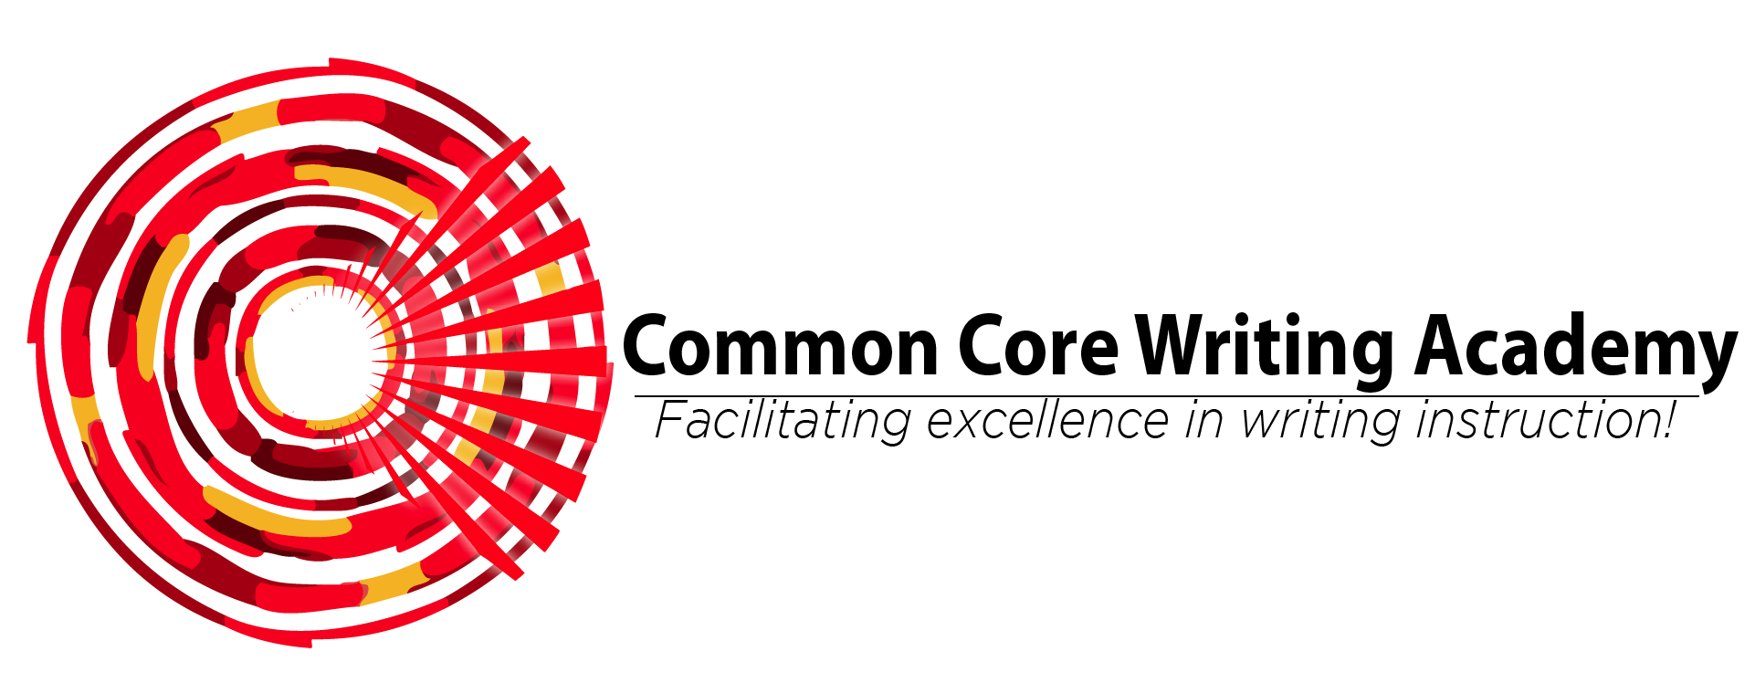

SF-182 Effective Instructional Behavior, Part I

Synopsis: This workshop provides participants with the knowledge and tools for designing age and grade appropriate lessons. Half of the day is spent in classroom observation to diagnose specific instructional behaviors, and the second half of the day is professional conversation beginning with feedback about the observation that leads to discussion of concepts, strategies, and tools for planning meaningful lessons that can be implemented the next day they return to their classrooms.

Target Audience: School staffs, including teachers, paraprofessionals, coaches, and administrators.

Goals:
- Build knowledge base of research about instructional and developmental learning best practices.
- Build knowledge, self-awareness, and skills for planning effective instructional practices.
- Establish a system for beginning professional learning communities.

Outcomes:
- Create lesson plans that use instructional best practices to deliver grade level content.
- Demonstrate self-awareness of areas for personal and collective growth in implementing instructional best practices.
- Model lessons designed around instructional best practices and provide feedback to colleagues.

Cost: The lump sum cost for this training is $4300 and includes consulting fee, materials, and travel costs.

For more information about this training package and to schedule, contact
Dr. Jennifer Byrne at (785) 331-8714 or jenniferbyrne52@gmail.com.

