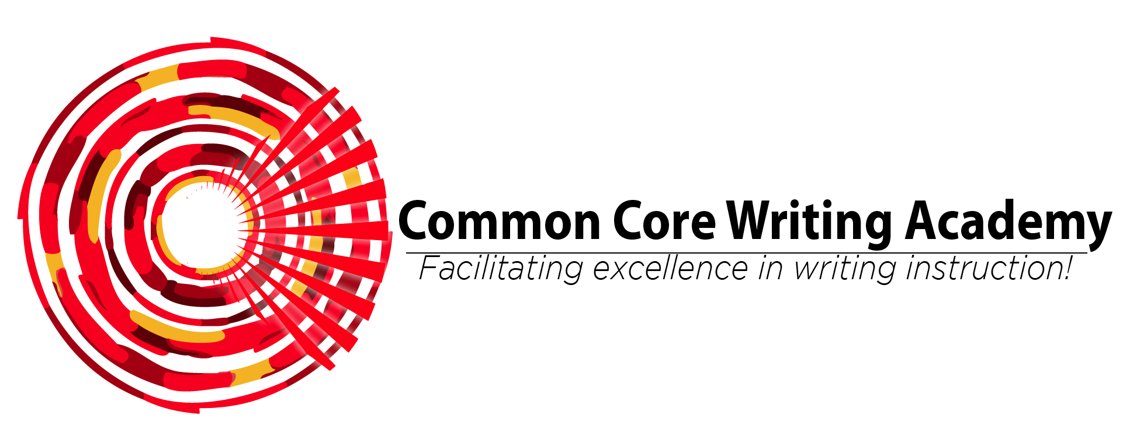

SF-182 Effective Instructional Behavior, Part II

Synopsis: The first half of this professional development begins with classroom observations to diagnose instructional delivery needs, followed by the second half, a professional conversation that provides participants with feedback about the diagnostic observations and concepts and tools for effective instructional delivery behaviors. Participants will leave with knowledge, strategies, and tools that they can use the next day they return to their respective classrooms.

Target Audience: School staffs, including teachers, paraprofessionals, coaches, and administrators.

Goals:
- Build knowledge base of research about classroom management best practices.
- Build knowledge, self-awareness, and skills for planning effective instructional delivery.

Outcomes:
- Create developmentally appropriate classroom procedures.
- Self-evaluate and set personal short and long-term goals for effective classroom student and adult behavior.
- Demonstrate developmentally appropriate plans for teaching students effective learning skills.

Cost: The lump sum cost for this training is $4300 and includes consulting fee, materials, and travel costs.

For more information about this training package and to schedule, contact Dr. Jennifer Byrne at (785) 331-8714 or jenniferbyrne52@gmail.com.

