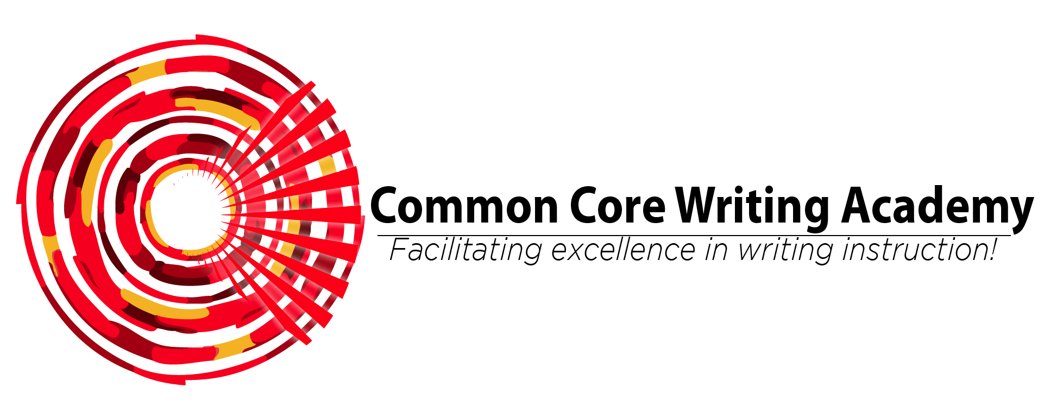
SF-182 Using Standards to Improve Instruction

Synopsis: This session begins with diagnostic classroom observations to determine rate of curriculum implementation, then follows with debriefing observations and professional conversation to provide participants with the knowledge and tools to analyze CCSS ELA curriculum standards and apply that knowledge to designing grade-level expectations and lesson plans for instruction.

Target Audience: School staffs, including teachers, paraprofessionals, coaches, and administrators.

Goals:
- Develop understanding of how to use state ELA state curriculum standards to frame planning for single-grade and multi-grade classrooms.
- Align classroom expectations for annual grade-level student academic growth to expectations for growth as described by the state.
- Practice using the framework of state ELA standards to plan grade-level appropriate daily lessons.

Outcomes:
• Understand the purpose of state ELA curriculum standards at the classroom level.
• Create standards-based ELA lessons that match adequate pacing for one year of ELA skills growth for students.
• Increase teacher ability to match daily ELA lesson components with prioritized state ELA curriculum standards.

Cost: The lump sum cost for this training is $4300 and includes consulting fee, materials, and travel costs.

For more information about this training package and to schedule, contact Dr. Jennifer Byrne at (785) 331-8714 or jenniferbyrne52@gmail.com.

